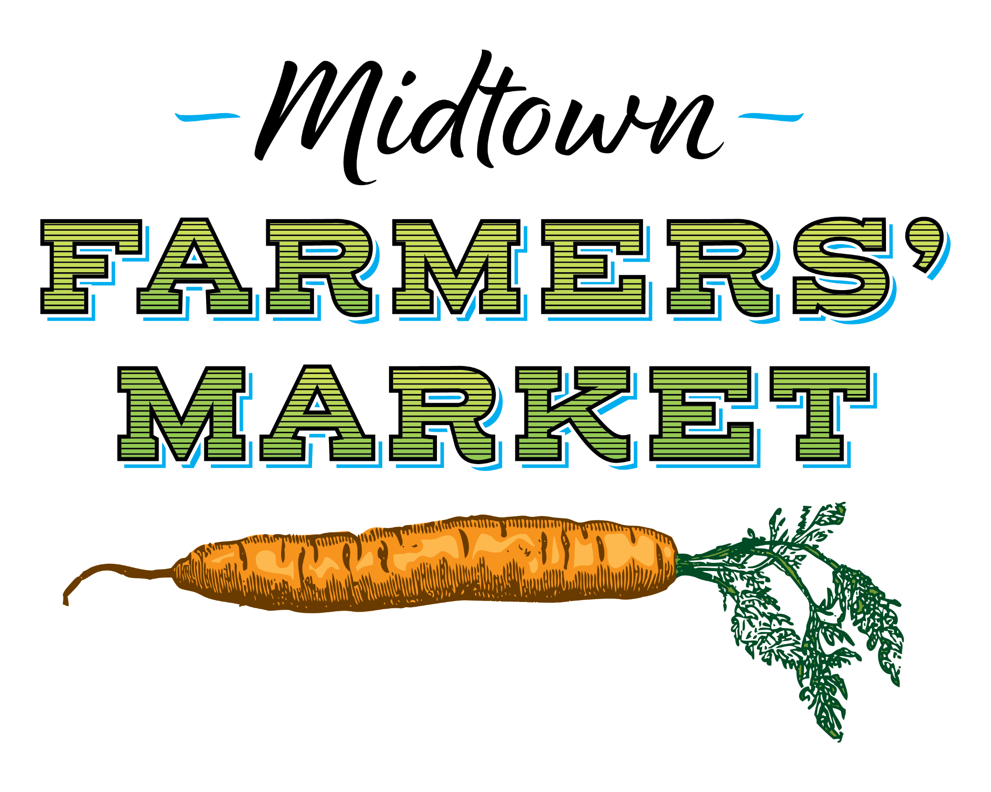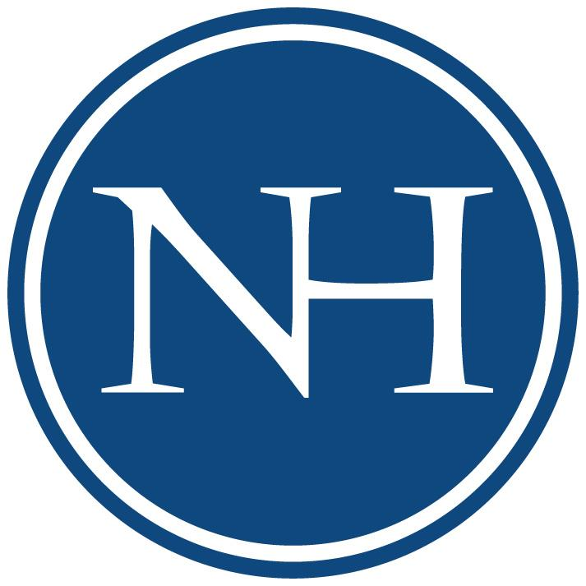

MIDTOWN EVENTS: FARMERS’ MARKET INTERN

(paid internship)

Midtown Events seeks highly motivated, self-starting students with a genuine interest in local farming, the agriculture industry, community-building, health and wellness, and sustainability. Must be dependable, hard-working, and a team player.

ABOUT MIDTOWN EVENTS, LLC: Midtown Events is dedicated to planning and producing events that enhance the sense of community at North Hills, a mixed-use development located in Midtown Raleigh.

ABOUT MIDTOWN FARMERS’ MARKET: Midtown Farmers’ Market takes place every Saturday, April 15 through November 4, from 8am to noon. We are a producers-only market offering locally-grown produce, prepared products, baked goods, and high quality, handmade crafts from local artisans - all produced within a 100-mile radius of Raleigh. Weekly programming aims to provide fun, community-building activities that educate the market community on local farming practices, seasonal produce, overall health and wellness, and sustainability.

INTERNSHIP DATES: Saturdays | April 15 - November 4

HOURS: 25 onsite Saturdays @ 5 hours each (7:15am to 12:15pm) + 30 hours total for marketing/special projects (about 1 hour from home per week). Onsite market dates and home hours will likely be divided by 2 interns.

JOB RESPONSIBILITIES:
- Assist with the setup and break down of the market including: tents, tables, signage, chairs, compost bins and other market/programming supplies as needed. Must be capable of lifting up to 50 lbs.
- General correspondence with market guests, vendors, public safety officers etc.
- Setup and supervise kids crafts and other onsite programming activities
- Take photos and videos, create reels, and post to social media “in real time”
- Add new contacts to market e-newsletter (weekly)
- Prepare a “produce of the week” section for weekly e-newsletter
- Act as an ambassador of North Hills - specifically looking for a professional attitude coupled with an energetic rapport - a customer service focused individual

PAY: $12/hour

PLEASE SUBMIT RESUME & REFERENCES TO:
Kate Dudeck | kdudeck@kanerealtycorp.com
Website: midtownfarmers.com | Instagram: @midtownfarmers

